Tips for Poster Presentations

Most papers presented at ISTSS are in poster format. That means posters are the primary way that we share the latest research and work being done in the traumatic stress field. This year at ISTSS, we will be trialing a new innovative format of poster that aims to more efficiently and effectively communicate research findings.

The following information will help you prepare your research results so that your colleagues get the most benefit from the poster presentation at the ISTSS Annual Meeting.

In designing these guidelines we have also worked closely with our colleagues at the European Society for Traumatic Stress Studies (ESTSS) to develop a system that will be consistent across both the ISTSS and ESTSS meetings.

POSTER SIZE AND SETTING UP

You will be provided with a space approximately one meter square (39 inches by 39 inches). Please prepare your poster so that it makes the most of this space but does not exceed the area. You will be provided thumbtacks to affix your poster to this space, but it is a good idea to bring extra.

In the interest of reducing paper-waste, we would encourage you not to bring handouts of your poster, but instead to have a single sign-up sheet, where colleagues can put their name and email, so that you can email a copy of your poster to interested people. Alternatively or additionally, you can use a QR code (discussed later) to allow attendees to link to an electronic version of your poster.

POSTER FORMAT
This new poster format that we are encouraging for #ISTSS2019 comes from work that has been widely circulated on social media - https://www.youtube.com/watch?v=1RwJbhkCA58

Content: Whether you use the recommended new format or stick with a traditional poster format, it is important that the information you provide is succinct and non-technical. Keep references and reviews of the literature to a minimum. Examples of each type of poster are presented on Page 3.

For the new poster format, consider your poster as divided in to approximately four sections. The key finding or ‘take home point’ of your research should be entered in very LARGE text in the middle two quarters of the poster. We then encourage you to color the middle section to align with the color-code that best reflects your topic area (described later). If you want to link your poster to a paper or further explanation of your project, you could add a QR Code. A guide on adding a QR code can be found here https://www.youtube.com/watch?v=NtwCTo7T9zg. You could also add a key image or table to this section, but only if it is important.

In the fourth quarter (“Ammo bar”) you can add any details that are important, such as Methods details and Figures/Tables that are central to your Results.

In the first quarter you could then add details under the following headings: Introduction; Method; Results; Discussion.

Of note, we are trialing this new method of poster design for 2019. However, you are of course welcome to use other designs based on your own personal preference. If you do choose to use a more traditional poster design, please ensure that:

- Text is never less than size 18 (size 24 is recommended)
- Titles are LARGE (e.g., size 36)
- Sections are clearly labelled – e.g., Introduction; Methods; Results; Conclusions
- You use standard font styles, such as Arial or Times New Roman
- Make use of underlines and bold

Programs like MS PowerPoint can be helpful in making your poster.

Diversity in research is greatly valued and an important consideration in every contribution. Whichever poster format you choose, and whichever color-code you are in, please ensure that you also highlight any considerations of diversity within your sample.

Color Code: These color-codes have been developed alongside our colleagues at ESTSS, with the plan to use the same coding scheme at both conferences. Please choose the color code that best reflects your topic area. If you use the new recommended format you might color the whole middle section (as shown below). If you use a traditional poster format you might color your title bar.

Mass violence and migration | TRAUMA IN  SPECIFIC  POPULATIONS
Child and adolescent trauma
Professionals (e.g., Military/veterans, journalists, health workers)
Public health | PATHOLOGY, ASSESSMENT & INTERVENTION
Biology & Medical
Assessment & diagnosis
Clinical interventions (e.g., treatment trials)
Mode, methods & ethics

Materials: Try to make your poster sturdy enough to withstand your trip to the meeting. Use colored paper or poster board to back sheets of 8 1/2 x 11” paper. You can also print your poster on manuscript paper that you can get enlarged at a copy store. If you choose this option use the "column" and "border” options in your Word processor to organize sections, and use portrait orientation and a small font (12 pt for the title, 8 pt. for the text). Use color (muted colors are best for the background, bright colors are OK for borders) in your poster.

New (recommended) format example:

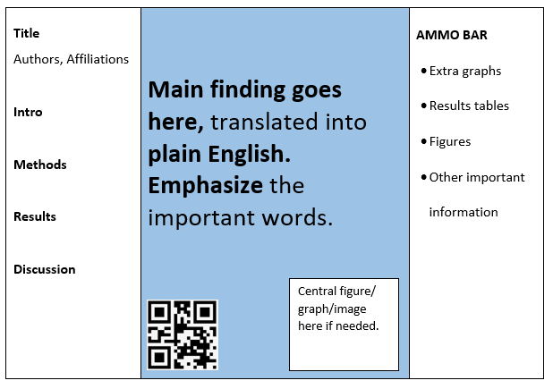

Example of traditional format example:

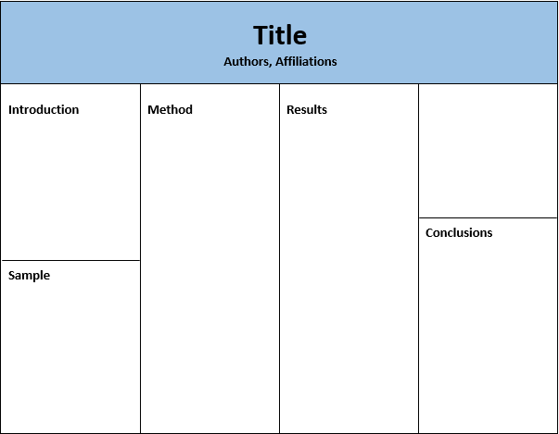

Thank you for presenting at ISTSS!

